LAPORAN PRAKTIK

MONGODB DENGAN PYTHON (PYMONGO)

Abdul Majid (225443001)



1AEC-1
TEKNOLOGI REKAYASA INFORMATIKA INDUSTRI
POLITEKNIK MANUFAKTUR BANDUNG
TAHUN AJARAN 2025/2026
BAB I
- Latihan 1
- Setup Lingkungan

Buat file maintenance.csv dengan isi seperti berikut
mesin,tanggal,biaya,teknisi
CNC-01,2023-10-05,1200000,Budi
CNC-02,2023-10-12,800000,Andi
CNC-01,2023-11-20,1500000,Siti
Mesin-Las,2023-11-22,500000,Budi
CNC-03,2023-12-01,1100000,Tono

Lalu buat sebuah script python untuk me-import data yang telah ada di maintenance.csv
Seperti ini:
import pandas as pd
from pymongo import MongoClient

client = MongoClient("mongodb://localhost:27017/")
db = client["latihan6"]
collection = db["maintenance"]

print("Membaca file maintenance.csv...")
df = pd.read_csv("maintenance.csv")

df["tanggal"] = pd.to_datetime(df["tanggal"])

data_records = df.to_dict(orient="records")

if data_records:
collection.delete_many({})

result = collection.insert_many(data_records)
print(f"Berhasil menyisipkan {len(result.inserted_ids)} dokumen ke koleksi 'maintenance'.")

Output:

- Jalankan Script Query

Buat sebuah script query ke database yang telah kita buat seperti dibawah ini
import pandas as pd
from pymongo import MongoClient

client = MongoClient("mongodb://localhost:27017/")
db = client["latihan6"]
collection = db["maintenance"]

print("=== 1. Mencari Dokumen dengan Biaya > 1.000.000 ===")
query_biaya = {"biaya": {"$gt": 1000000}}
data_biaya = list(collection.find(query_biaya))

df_biaya = pd.DataFrame(data_biaya)
if not df_biaya.empty:
print(df_biaya.drop(columns=["_id"]).to_string(index=False))
else:
print("Tidak ada data yang ditemukan.")

print("\n=== 2. Melakukan Update Data ===")
query_update = {"mesin": "CNC-01", "biaya": 1200000}
update_values = {"$set": {"teknisi": "Dewi"}}

update_result = collection.update_many(query_update, update_values)
print(f"Berhasil memperbarui {update_result.modified_count} dokumen (Teknisi diubah menjadi 'Dewi').")

print("\n=== 3. Menghitung Total Biaya per Bulan ===")
pipeline = [
{
"$group": {
"_id": {"$dateToString": {"format": "%Y-%m", "date": "$tanggal"}},
"total_biaya": {"$sum": "$biaya"}
}
},
{
"$sort": {"_id": 1}
}
]

agg_result = list(collection.aggregate(pipeline))
df_agg = pd.DataFrame(agg_result)

if not df_agg.empty:
df_agg.rename(columns={"_id": "Bulan"}, inplace=True)
print(df_agg.to_string(index=False))
else:
print("Tidak ada data agregasi.")

Output:
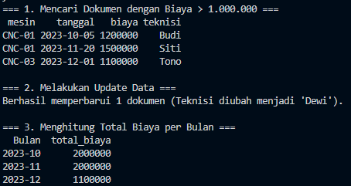

- Latihan 2

Buat dua buah script, satu publisher dan satu subscriber

Script publisher
import paho.mqtt.client as mqtt
import time
import json
import random
from paho.mqtt.enums import CallbackAPIVersion

broker = "broker.hivemq.com"
port = 1883
topic = "pabrik/produksi"

client = mqtt.Client(CallbackAPIVersion.VERSION1)

print(f"Menghubungkan ke broker {broker}...")
client.connect(broker, port, 60)

print("Mulai mengirim data produksi (Tekan Ctrl+C untuk berhenti)...")
try:
while True:
data = {
"batch": f"B-{random.randint(1000, 9999)}",
"mesin": random.choice(["Mesin-A", "Mesin-B", "Mesin-C", "CNC-01"]),
"jumlah": random.randint(100, 500),
"reject": random.randint(0, 50)
}

payload = json.dumps(data)
client.publish(topic, payload)

print(f"Data terkirim -> {payload}")
time.sleep(3)

except KeyboardInterrupt:
print("\nPublisher dihentikan.")
client.disconnect()

Output:
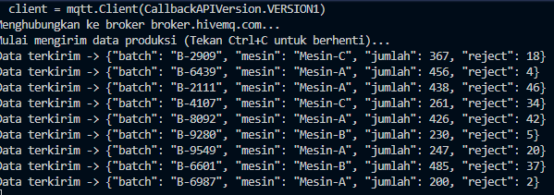

Script Subscriber
import paho.mqtt.client as mqtt
import json
from datetime import datetime
from pymongo import MongoClient

mongo_client = MongoClient("mongodb://localhost:27017/")
db = mongo_client["latihan6"]
col = db["produksi_mqtt"]

broker = "broker.hivemq.com"
port = 1883
topic = "pabrik/produksi"

def on_connect(client, userdata, flags, rc):
print(f"Terhubung ke MQTT Broker dengan kode hasil: {rc}")
client.subscribe(topic)
print(f"Berlangganan pada topik: {topic}")

def on_message(client, userdata, msg):
payload = msg.payload.decode()
data = json.loads(payload)

data["timestamp"] = datetime.now()

jumlah = data.get("jumlah", 0)
reject = data.get("reject", 0)

if jumlah > 0:
reject_rate = (reject / jumlah) * 100

if reject_rate > 5.0:
print(f"\n[PERINGATAN] Reject Rate tinggi! ({reject_rate:.2f}%) pada {data['mesin']}")
data["peringatan"] = True

col.insert_one(data)

data_to_print = data.copy()
data_to_print.pop('_id', None)
print(f"Tersimpan di DB: {data_to_print}")

client = mqtt.Client()
client.on_connect = on_connect
client.on_message = on_message

print(f"Menghubungkan ke broker {broker}...")
client.connect(broker, port, 60)

try:
client.loop_forever()
except KeyboardInterrupt:
print("\nSubscriber dihentikan.")
client.disconnect()

Output:
